EXPERIMENT NO: 9 b
AIM: WAP to Design a class in cpp to convert class data type to another class data type

CODE :-
#include <iostream>
using namespace std;
class Duration {
private:
int mins;
public:
Duration(int m = 0) {
mins=m;
}
void display() const {
cout << "Duration in mins: " << mins<< endl;
}
};
class Time {
private:
int hrs, mins;
public:
Time(int h, int m){
hrs=h;
mins=m;
}

~Time() {
}
operator Duration() {
int total = hrs * 60 + mins;
return Duration(total);
}
};
int main() {
Time t1(3, 45);
Duration d1 = t1;
d1.display();
cout << endl;
return 0;
}

OUTPUT
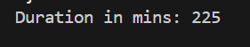

EXPERIMENT NO: 10

CODE :-
#include <iostream>
using namespace std;
OUTPUT
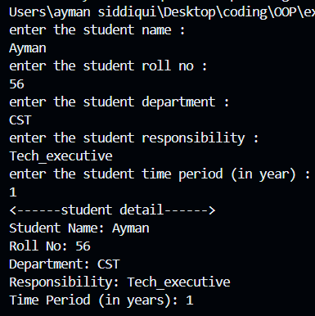
class student
{
protected:
string name;
int roll_no;
string dept;

public:
student()
{
cout << "enter the student name : " << endl;
cin >> name;
cout << "enter the student roll no : " << endl;
cin >> roll_no;
cout << "enter the student department : " << endl;
cin >> dept;
}
};

class general : public student
{
protected:
string respon;
float year;
public:
general() : student()
{
cout << "enter the student responsibility : " << endl;
cin >> respon;
cout << "enter the student time period (in year) : " << endl;
cin >> year;

cout<<"<------student detail------>"<<endl;

cout << "Student Name: " << name << endl;
cout << "Roll No: " << roll_no << endl;
cout << "Department: " << dept << endl;
cout << "Responsibility: " << respon << endl;
cout << "Time Period (in years): " << year << endl;
}
};
int main()
{
general g;
return 0;
}

EXPERIMENT NO: 11
CODE :-
#include<iostream>
using namespace std;
OUTPUT
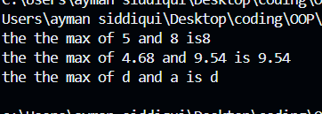
template<typename T>
T Max(T a, T b){
return (a>b)?a:b;
}
int main (){
cout<<"the the max of 5 and 8 is"<<Max<int>(5,8)<<endl;
cout<<"the the max of 4.68 and 9.54 is "<<Max<float>(4.68,9.54)<<endl;
cout<<"the the max of d and a is "<<Max<char>('d','a')<<endl;
return 0;
}
CODE :-
#include<bits/stdc++.h>
using namespace std;
OUTPUT
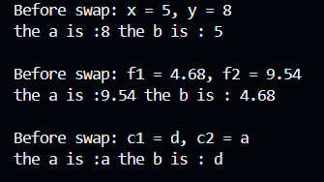
template<typename t>
void Swap(t &a , t &b){
swap(a,b);
cout<<"the a is :"<<a<<" the b is : "<<b<<endl;
}
int main (){
int x = 5, y = 8;
float f1 = 4.68, f2 = 9.54;
char c1 = 'd', c2 = 'a';

cout << "Before swap: x = " << x << ", y = " << y << endl;
Swap(x, y);
cout << "\nBefore swap: f1 = " << f1 << ", f2 = " << f2 << endl;
Swap(f1, f2);
cout << "\nBefore swap: c1 = " << c1 << ", c2 = " << c2 << endl;
Swap(c1, c2);
return 0;
}

EXPERIMENT NO: 12
CODE:-
#include <bits/stdc++.h>
using namespace std;
int main() {
try {
OUTPUT
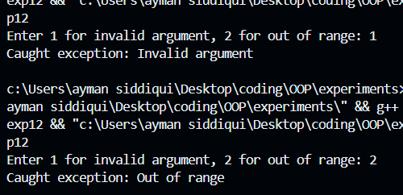
int choice;
cout << "Enter 1 for invalid argument, 2 for out of range: ";
cin >> choice;
if (choice == 1)
throw invalid_argument("Invalid argument");
else if (choice == 2)
throw out_of_range("Out of range");
else
throw "Unknown error";
}
catch (const invalid_argument& e) {
cout << "Caught exception: " << e.what() << endl;
}
catch (const out_of_range& e) {
cout << "Caught exception: " << e.what() << endl; 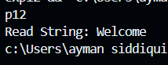
}
catch (...) {
cout << "Caught an unknown exception." << endl;
}
return 0;
}

CODE:-
#include <bits/stdc++.h>
using namespace std;
OUTPUT
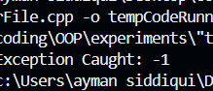
int main() {
int x = 7;
try {
if (x % 2 != 0) {

// Throwing int
throw -1;
}
}
// Catching int
catch (int e) {
cout << "Exception Caught: " << e;
}

return 0;
}

CODE:-
#include <iostream>
#include <stdexcept>
OUTPUT
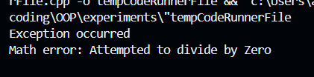
using namespace std;
float Division(float num, float den)
{
if (den == 0) {
throw runtime_error("Math error: Attempted to divide by Zero\n");
}
return (num / den);
}
int main()
{
float numerator, denominator, result;
numerator = 12.5;
denominator = 0;
try {
result = Division(numerator, denominator);
cout << "The quotient is "
<< result << endl;
}
catch (runtime_error& e) {
cout << "Exception occurred" << endl
<< e.what();
}

}

EXPERIMENT NO: 13
CODE:
#include<bits/stdc++.h>
using namespace std;
OUTPUT
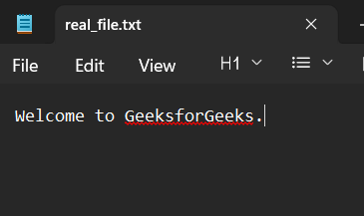
int main() {
// Open a file
ofstream file("real_file.txt");

// Write the string to the file
file << "Welcome to GeeksforGeeks.";
return 0;
}

CODE:
#include<bits/stdc++.h>
using namespace std;
OUTPUT
int main()
{
// Open a file in read mode
ifstream file("real_file.txt");
string s;
// Read string from the file
file >> s;
cout << "Read String: " << s;
return 0;
}

CODE:
#include<bits/stdc++.h>
using namespace std;
OUTPUT
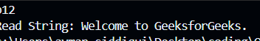
int main()
{
// Open a file in read mode
ifstream file("real_file.txt");
string s;
// Read string from the file
getline(file, s);
cout << "Read String: " << s;
// Close the file
file.close();
return 0;
}

